**Assignment 1) Creation of Virtual Directory, Home directory, Home page, hosting of website**

**Assignment 2) Demonstrate Page Life Cycle of ASP.NET. Use important page events for your demonstration.**

1. File-New Website
2. Take 1 Label and 1 Button
3. Write Following Code

using System;

using System.Configuration;

using System.Data;

using System.Linq;

using System.Web;

using System.Web.Security;

using System.Web.UI;

using System.Web.UI.HtmlControls;

using System.Web.UI.WebControls;

using System.Web.UI.WebControls.WebParts;

using System.Xml.Linq;

public partial class _Default : System.Web.UI.Page

{

protected void Page_PreInit(object sender, EventArgs e)

{

//Work and It will assign the values to label.

Label1.Text = Label1.Text + "<br/>" + "PreInit";

}

protected void Page_Init(object sender, EventArgs e)

{

//Work and It will assign the values to label.

Label1.Text = Label1.Text + "<br/>" + "Init";

}

protected void Page_InitComplete(object sender, EventArgs e)

{

//Work and It will assign the values to label.

Label1.Text = Label1.Text + "<br/>" + "InitComplete";

}

protected override void OnPreLoad(EventArgs e)

{

//Work and It will assign the values to label.

//If the page is post back, then label contrl values will be loaded from view state.

//E.g: If you string str = Label1.Text, then str will contain viewstate values.

Label1.Text = Label1.Text + "<br/>" + "PreLoad";

}

protected void Page_Load(object sender, EventArgs e)

{

//Work and It will assign the values to label.

Label1.Text = Label1.Text + "<br/>" + "Load";

}

protected void Button1_Click(object sender, EventArgs e)

{

//Work and It will assign the values to label.

Label1.Text = Label1.Text + "<br/>" + "btnSubmit_Click";

}

protected void Page_LoadComplete(object sender, EventArgs e)

{

//Work and It will assign the values to label.

Label1.Text = Label1.Text + "<br/>" + "LoadComplete";

}

protected override void OnPreRender(EventArgs e)

{

//Work and It will assign the values to label.

Label1.Text = Label1.Text + "<br/>" + "PreRender";

}

protected override void OnSaveStateComplete(EventArgs e)

{

//Work and It will assign the values to label.

//But "SaveStateComplete" values will not be available during post back. i.e. View state.

Label1.Text = Label1.Text + "<br/>" + "SaveStateComplete";

}

protected void Page_UnLoad(object sender, EventArgs e)

{

//Work and it will not effect label contrl, view stae and post back data.

Label1.Text = Label1.Text + "<br/>" + "UnLoad";

}

}

1. Run

**OUTPUT:-**

**Before Button Click After Button Click**

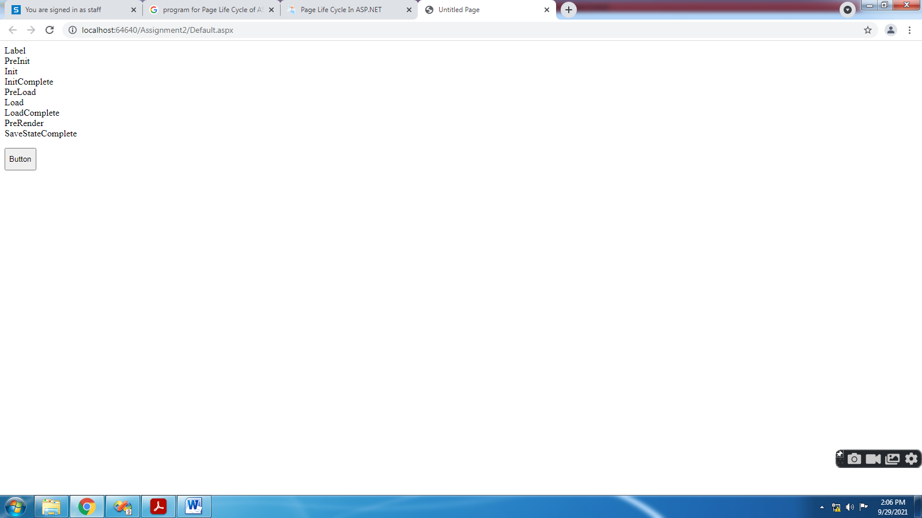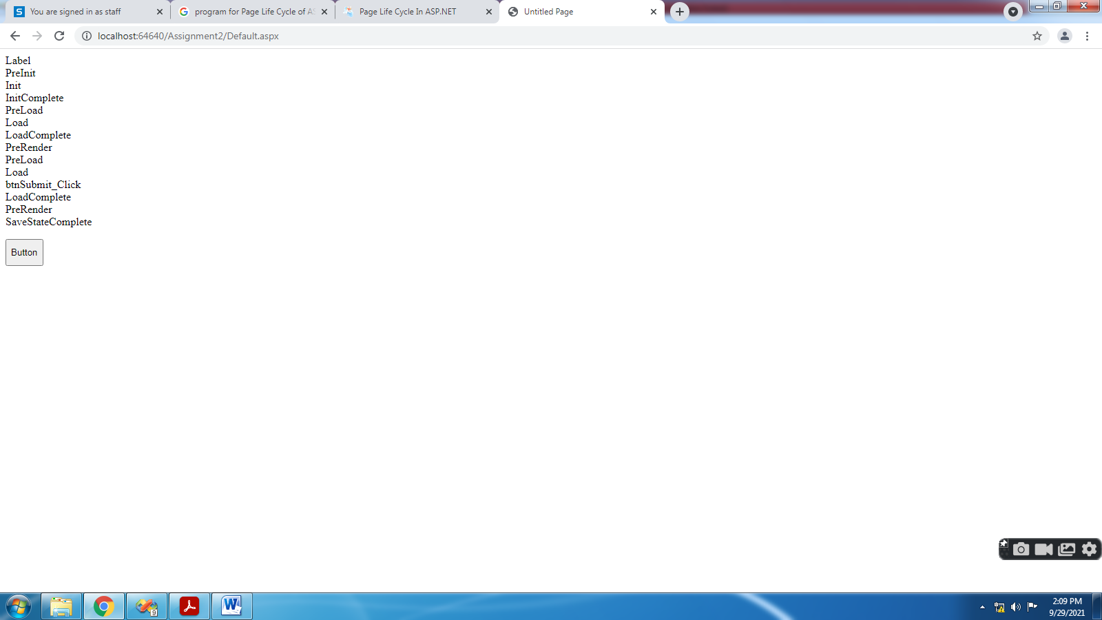

**Assignment 4) Demonstrate concept of postback and viewstate using web form server controls of ASP.NET**

1. File-New Website
2. Take 2 DropDownList2, 2nd having property EnableViewState="false"
3. Write Following Code

using System;

using System.Configuration;

using System.Data;

using System.Linq;

using System.Web;

using System.Web.Security;

using System.Web.UI;

using System.Web.UI.HtmlControls;

using System.Web.UI.WebControls;

using System.Web.UI.WebControls.WebParts;

using System.Xml.Linq;

public partial class _Default : System.Web.UI.Page

{

protected void Page_Load(object sender, EventArgs e)

{

bind1();

bind2();

}

public void bind1()

{

ListItem l1 = new ListItem("India");

ListItem l2 = new ListItem("US");

ListItem l3 = new ListItem("Japan");

DropDownList1.Items.Add(l1);

DropDownList1.Items.Add(l2);

DropDownList1.Items.Add(l3);

}

public void bind2()

{

ListItem l1 = new ListItem("India");

ListItem l2 = new ListItem("US");

ListItem l3 = new ListItem("Japan");

DropDownList2.Items.Add(l1);

DropDownList2.Items.Add(l2);

DropDownList2.Items.Add(l3);

}

protected void Button1_Click(object sender, EventArgs e)

{

}

}

1. Run

**OUTPUT:-**

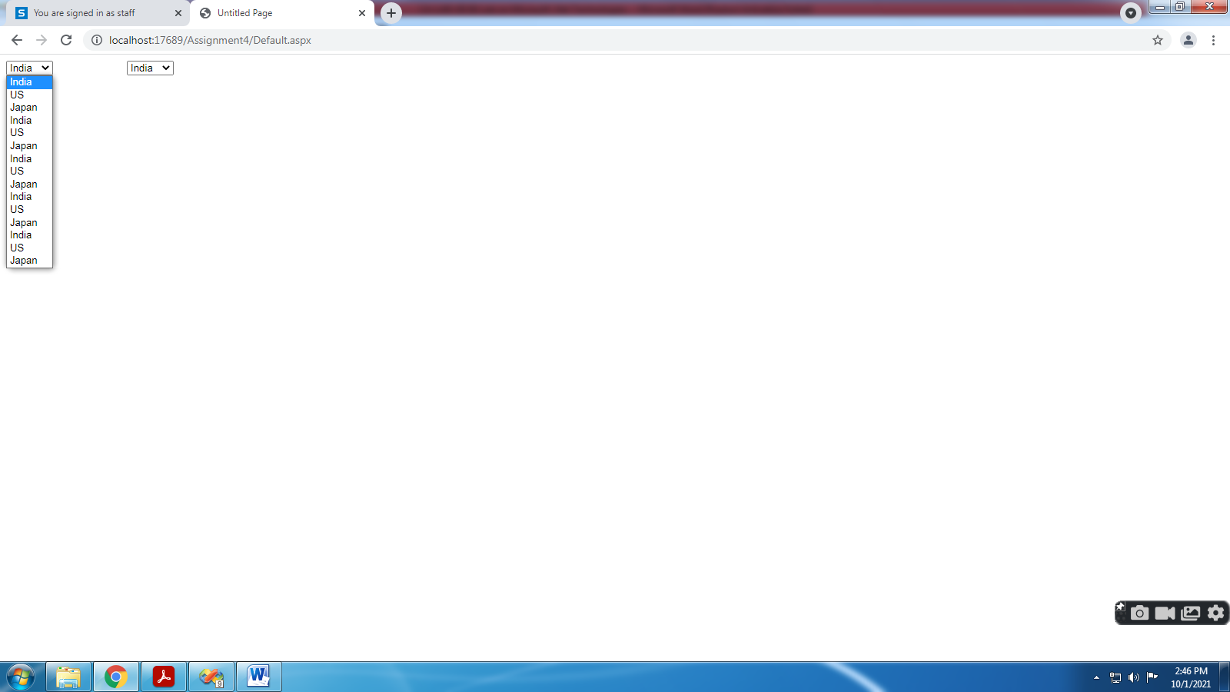 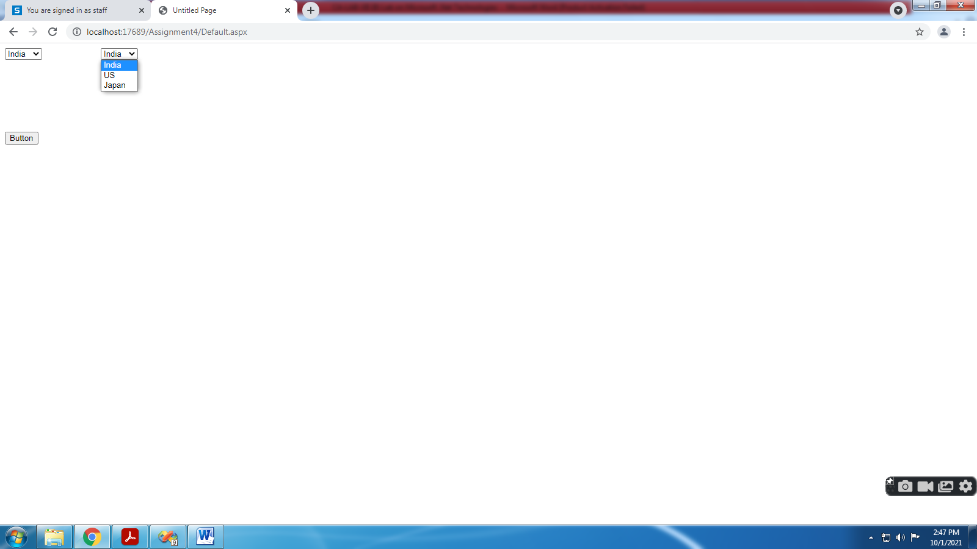

**Assignment 6) Demonstrate DropDownList box, CheckButtonList, RadioButtonList controls.**

1. File-New Website
2. Write Following Code

using System;

using System.Configuration;

using System.Data;

using System.Linq;

using System.Web;

using System.Web.Security;

using System.Web.UI;

using System.Web.UI.HtmlControls;

using System.Web.UI.WebControls;

using System.Web.UI.WebControls.WebParts;

using System.Xml.Linq;

public partial class _Default : System.Web.UI.Page

{

protected void Page_Load(object sender, EventArgs e)

{

}

protected void Button1_Click(object sender, EventArgs e)

{

Label1.Text = DropDownList1.SelectedValue.ToString();

Label2.Text = "Selected Item(s):<br /><br />";

for (int i = 0; i < CheckBoxList2.Items.Count; i++)

{

if (CheckBoxList2.Items[i].Selected)

{

Label2.Text += CheckBoxList2.Items[i].Text + "<br />";

}

}

Label3.Text = "Selected Item(s):<br /><br />";

for (int i = 0; i < RadioButtonList1.Items.Count; i++)

{

if (RadioButtonList1.Items[i].Selected)

{

Label3.Text += RadioButtonList1.Items[i].Text + "<br />";

}

}

}

}

1. Run

**OUTPUT:-**

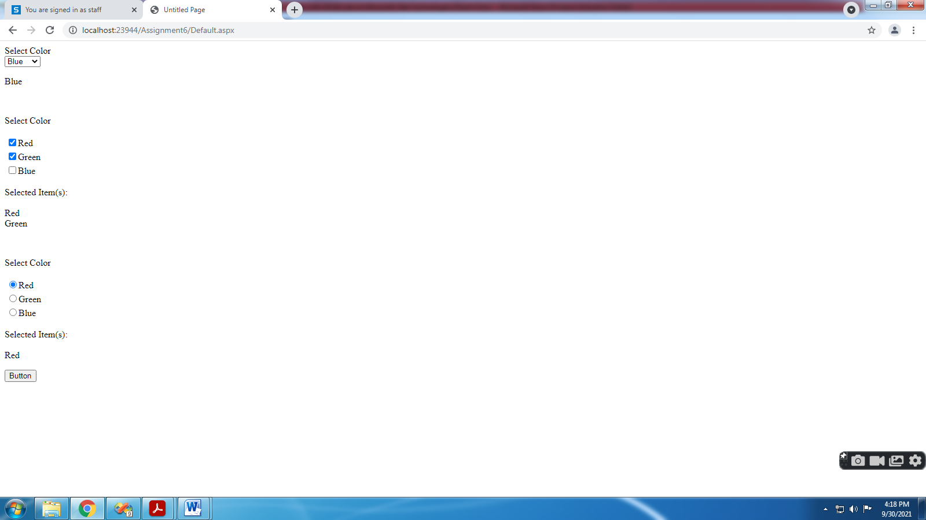

**Assignment 7) Demonstrate Databinding using Hashtable, ArraryList, DataTable data sources.**

1. Write Following Code in Default.aspx.cs

using System.Data;

using System.Data.SqlClient;

using System.Collections;

using System.Collections.Generic;

public partial class _Default : System.Web.UI.Page

{

protected void Page_Load(object sender, EventArgs e)

{

SqlConnection con = new SqlConnection("Data Source=.\\SQLEXPRESS;AttachDbFilename=I:\\2021-22\\Subjects\\CA-305(B) Microsoft .Net Technologies\\CA-LAB-XII (B) Lab on Microsoft .Net Technologies\\Assignment7\\App_Data\\Database.mdf;Integrated Security=True;User Instance=True");

**DataTable ds = new DataTable();**

SqlDataAdapter sde = new SqlDataAdapter("select * from student", con);

sde.Fill(ds);

GridView1.DataSource = ds;

GridView1.DataBind();

**ArrayList list = new ArrayList();**

list.Add("AAAA");

list.Add("BBBB");

list.Add("CCCC");

GridView2.DataSource =list;

GridView2.DataBind();

**Hashtable hashItems = new Hashtable();**

hashItems.Add("4","GGGG");

hashItems.Add("5","HHHH");

hashItems.Add("6","IIII");

hashItems.Add("7","JJJJ");

GridView3.DataSource = hashItems;

GridView3.DataBind();

}

}

1. For **Hashtable** Write Following Code in Default.aspx

<asp:GridView ID="GridView3" runat="server"AutoGenerateColumns="false">

<Columns>

**<asp:BoundField DataField="key" HeaderText="Roll No" />**

**<asp:BoundField DataField="value" HeaderText="Name" />**

</Columns>

</asp:GridView>

**OUTPUT:-**

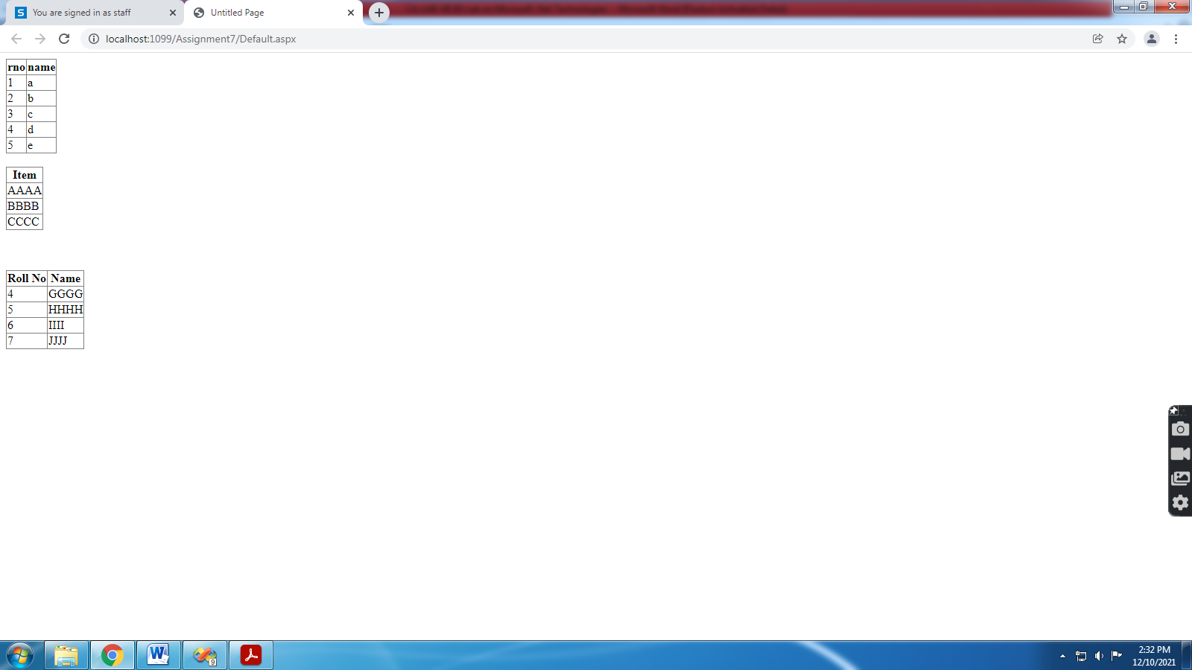

**Assignment 8) Demonstrate Repeater control with the help of various templates.**

1. Right Click on **App_Data** in **Solution Explorer**
2. Add New Item select **SQL Server Database** and give database name
3. In **Server Explorer** right click on **Tables,** select **Add New Table**
4. Right click on your table and select **Show Table Data** and insert records
5. Take **GridView** from **Data** click on **Choose Data Source, Database,** select your database/table/fields
6. Click on **Test Query** and **Finish**
7. 

Add Following code in Source view

<table border =2>

<asp:Repeater ID="Repeater1" runat="server"

DataSourceID="SqlDataSource1">

<HeaderTemplate >

<tr ><td style ="background-color:Lime ;">ROLL NO</td>

<td style ="background-color:Lime ;">NAME</td></tr>

</HeaderTemplate>

<ItemTemplate >

<tr><td><%#Eval("rno") %></td>

<td><%#Eval("name") %></td></tr></ItemTemplate>

<AlternatingItemTemplate >

<tr><td style ="background-color :Gray ;"><%#Eval("rno") %></td>

<td style ="background-color :Gray;"><%#Eval("name")%> </td></tr>

</AlternatingItemTemplate>

</asp:Repeater> </table>

8.Save , BUILT & RUN .

**OUTPUT:-**

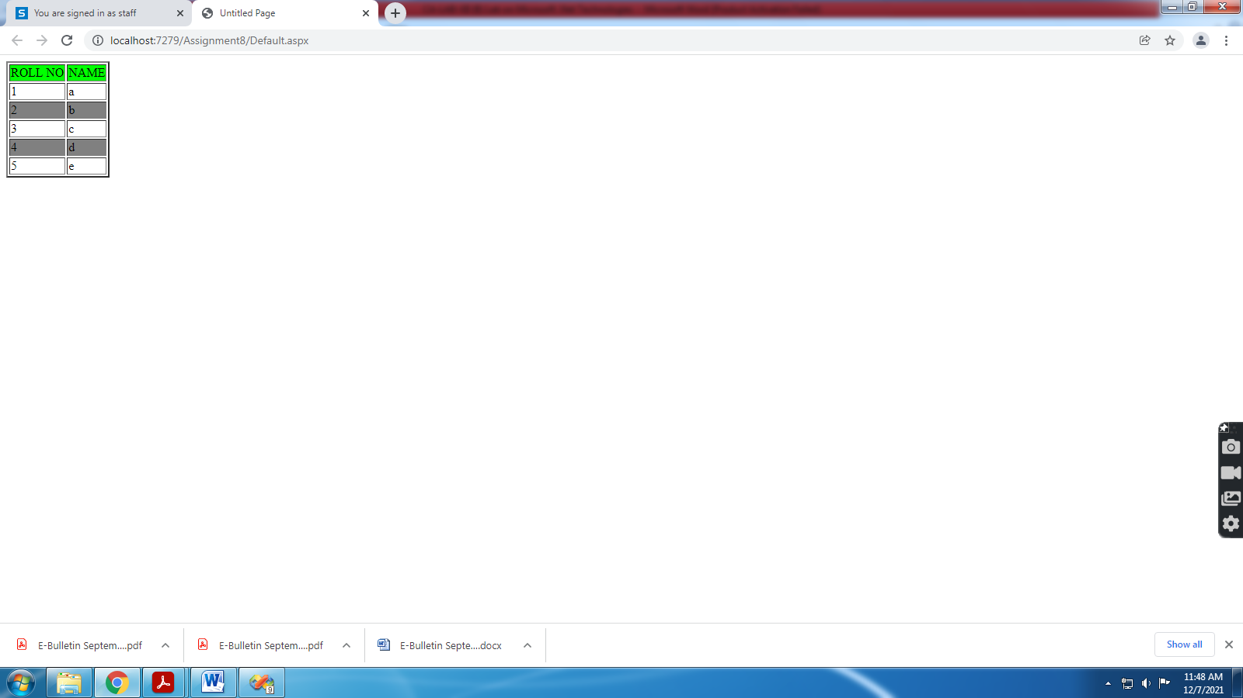

**Assignment 9) Demonstrate paging, sorting, filtering of data in asp:DataGrid/DataGridView.**

1. Right Click on **App_Data** in **Solution Explorer**
2. Add New Item select **SQL Server Database** and give database name
3. In **Server Explorer** right click on **Tables,** select **Add New Table**
4. Right click on your table and select **Show Table Data** and insert records
5. Take **GridView** from **Data** click on **Choose Data Source, Database,** select your database/table/fields
6. Click on **Test Query** and **Finish**
7. Click on **GridView** and **Tick Enable Paging, Enable Sorting** and set **PageSize** property.
8. Save and Run

**OUTPUT:-**

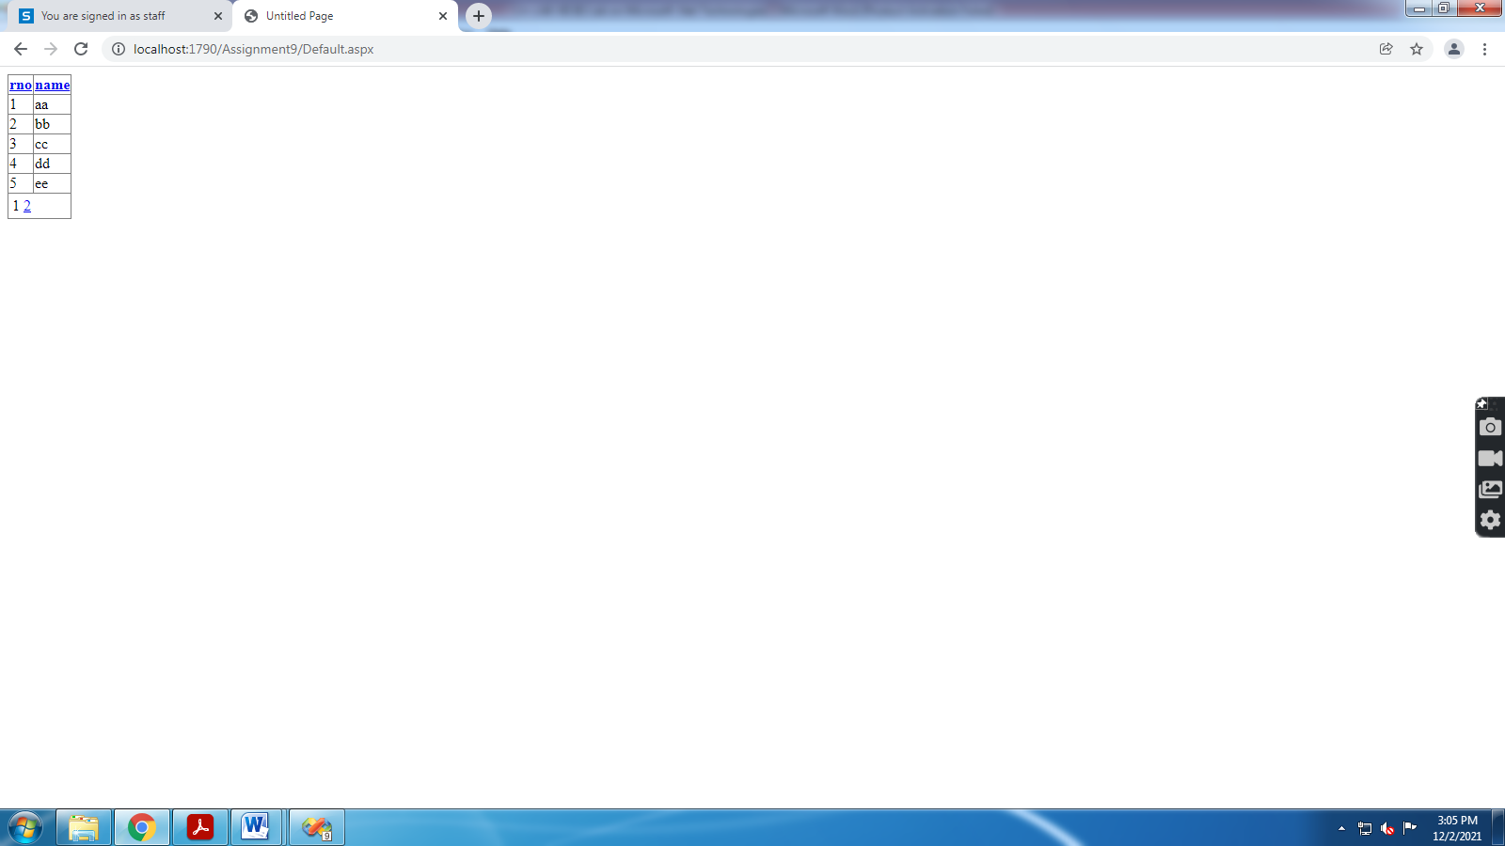

**Assignment 16) Demonstrate creation of simple/complex DataReader/DataSet Objects.**

1. Right Click on **App_Data** in **Solution Explorer**
2. Add New Item select **SQL Server Database** and give database name
3. In **Server Explorer** right click on **Tables,** select **Add New Table**
4. Right click on your table and select **Show Table Data** and insert records
5. Add 3 TextBoxes , 3 Buttons(INSERT,UPDATE,DELETE) & 1 GridView control to Default.aspx Page
6. Add Following Code
7. **DataReader:-**
8. using System.Data;
9. using System.Data.SqlClient;
10. public partial class _Default : System.Web.UI.Page
11. {
12. SqlConnection con = new SqlConnection("Data Source=.\\SQLEXPRESS;AttachDbFilename=I:\\2021-22\\Subjects\\CA-305(B) Microsoft .Net Technologies\\CA-LAB-XII (B) Lab on Microsoft .Net Technologies\\Assignment16\\App_Data\\Database.mdf;Integrated Security=True;User Instance=True");
13. SqlDataReader dr;
14. protected void Page_Load(object sender, EventArgs e)
15. {
16. if (!IsPostBack)
17. getdata();
18. }
19. void getdata()
20. {
21. SqlCommand cmd = new SqlCommand("select * from student", con);
22. con.Open();
23. dr = cmd.ExecuteReader();
24. GridView1.DataSource = dr;
25. GridView1.DataBind();
26. con.Close();
27. }
28. protected void Button1_Click(object sender, EventArgs e)
29. {
30. SqlCommand cmd1 = new SqlCommand("insert into student values(" + Convert
31. .ToInt32(TextBox1.Text) + ",'" + TextBox2.Text + "'," + Convert
32. .ToInt32(TextBox3.Text) + ")", con);
33. con.Open();
34. cmd1.ExecuteNonQuery();
35. con.Close();
36. getdata();
37. }
38. protected void Button2_Click(object sender, EventArgs e)
39. {
40. SqlCommand cmd2 = new SqlCommand("Update student set name='" + TextBox2.Text + "',mark=" +
41. Convert.ToInt32(TextBox3.Text) + "where rno=" + Convert.ToInt32(TextBox1.Text), con);
42. con.Open();
43. cmd2.ExecuteNonQuery();
44. con.Close();
45. getdata();
46. }
47. protected void Button3_Click(object sender, EventArgs e)
48. {
49. SqlCommand cmd3 = new SqlCommand("Delete from student Where rno=" +
50. Convert.ToInt32(TextBox1.Text), con);
51. con.Open();
52. cmd3.ExecuteNonQuery();
53. con.Close();
54. getdata();
55. }
56. }

**OUTPUT:-**

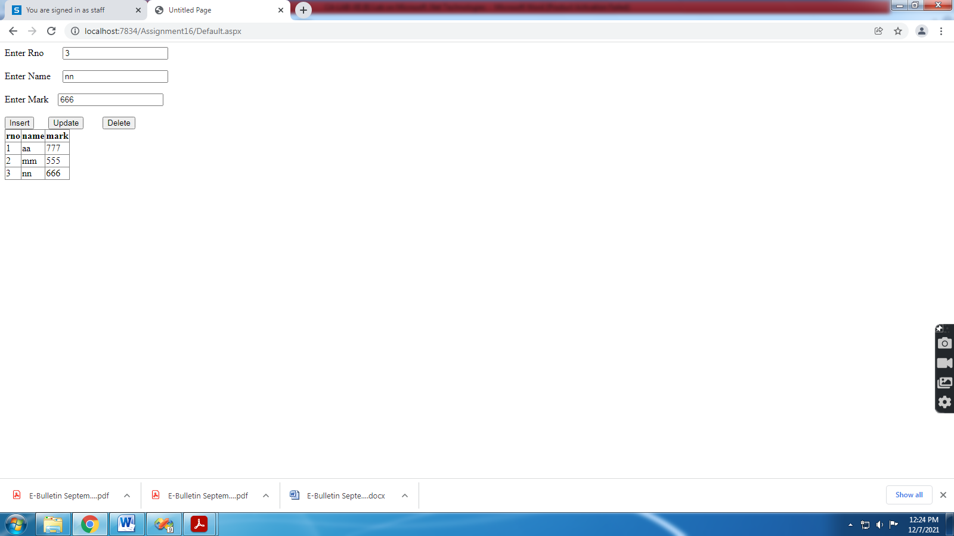

**DataSet:-**

using System.Data;

using System.Data.SqlClient;

public partial class _Default : System.Web.UI.Page

{

SqlConnection con = new SqlConnection("Data Source=.\\SQLEXPRESS;AttachDbFilename=I:\\2021-22\\Subjects\\CA-305(B) Microsoft .Net Technologies\\CA-LAB-XII (B) Lab on Microsoft .Net Technologies\\Assignment16A\\App_Data\\Database.mdf;Integrated Security=True;User Instance=True");

protected void Page_Load(object sender, EventArgs e)

{

if (!IsPostBack)

getdata();

}

void getdata()

{

**DataSet ds = new DataSet();**

SqlDataAdapter sde = new SqlDataAdapter("select * from student", con);

sde.Fill(ds);

GridView1.DataSource = ds;

GridView1.DataBind();

}

}